Where Are You, My Bride? You Have Neglected Me
June 22, 2017
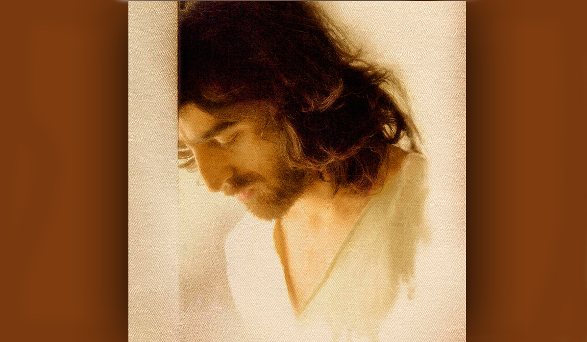
Lord Jesus, please give us the grace to persevere in prayer and things pleasing to You. Please deliver us from the dangers all around us that would steal us away from You. And please bring back the sheep that have wandered into the desert. Amen

My time with Jesus has been so rich, we have danced hours away in complete abandon, thinking of nothing but one another. I finished the lyrics to a song that expresses that, and hopefully it will soon be up. But for several nights we have danced and even Holy Spirit and Father God have come to join us in the celebration of our love. I don’t think I will ever get over the tender love they have for us. It continually amazes me how in love they are with each of us.

Dear Heartdwellers, I've noticed a drop in views and I think summertime has really got people distracted. I was concerned, so I did ask the Lord as we started our time together.

'My beautiful savior, I don’t know what to do about the shortage of provision and drop in views? Is this my fault, Lord? Have I missed something or been unfaithful?'

"Leave this in My hands, Clare." Jesus began. "Did I not just tell you I have prepared a feast but no one showed up?"

Yeah, that was a rhema card I got the other day and I wondered what it was about.

He continued, "My children are highly distracted and taken up with worldly pursuits. If I were not there for some of them, they would be in dire straits. But I have sat alone many, many nights when I should have been with My Bride. She is very busy with the world, and I miss her. The issues you are having are not your fault. You do pray for them, you do present the messages, but many in this moment don’t care. They have been invited to other activities and given in to neglecting Me.

"It is good for you to share this with them, Clare. My Brides, what is happening to your spiritual lives? Where is that sweetness you used to have towards Me? It has turned to neglect, and you are drifting further away from Me. Do you know this is the enemy’s campaign against you and this channel, because he is so threatened by your intimate relationship with Me?

"You cannot maintain the pace climbing the mountain of holiness without staying tucked into My arms, safe and sound. Because you have chosen worldly activities over prayer and holy reading and Scripture, you are slipping away from Me and dangerously close to a fall. This is no time to take chances with maintaining your faith by not being faithful to pray. Anytime you drift, it is dangerous. Many of you have fallen into traps cleverly laid in your life to detour you away from the precious devotion you had for Me.

"For those of you who have persevered in spite of numerous invitations, which you have turned down so you could be with Me, I have caravans of graces headed your way. Please continue to be faithful to this Channel, as it has many enemies spreading slanderous lies. As you pray and bless My channel, I bless you as well. Your faithfulness has captured My heart and I long to show you My appreciation.

"Don’t grow weary in well-doing, My doves. Continue to care for the poor where you find them. Continue to pray for those who are homeless and struggling with various issues, making their lives very difficult at home or even for those on the street. And those who are confined to bed and sick.

"The summertime is loaded with many distractions and dangers. Tempers flare, flesh is everywhere, men and women are weak, and if they are not praying as they should, the dangers of falling into sin are great. It truly grieves Me when this vessel posts a very true and good message from Me but the audience is on vacation…spiritually. May I say, it is never safe to go on a spiritual vacation? Any lapse is like a breach in the wall for the enemy to climb through.

"I have been guiding you here for a long time and those of you who have grown spiritually have really tremendous needs for wisdom and protection, because your intimacy with Me is so very threatening to the enemy, and you wear a target on your backs. You cannot leave your guard down, even for a day."

Boy, I've noticed that. If a day gets really hectic, it's serious the next day, because I can see things lining up against me.

Jesus continued, "So much is planned against you in the 24 hours you are not praying and staying vigilant. I want you to immediately recognize the enemy when he walks in the door, even pretending to be good. There are many deceitful people who will rob you of your treasure if you do not guard it vigilantly.

"And to those of you, My precious handful. We are continuing the climb to stunning vistas, things you never even imagined you would see. Be alert to My visitations taking you to Heaven. I will reach out My hand to yours and we will simply step into that dimension. I wish to relieve many of you of the stress and tension you have accumulated on this journey. And as you rest in Me, even with music, and you see Me, be ready and willing to take My hand as we visit the heavenly places I want to share with you.

"These trips begin very simply, by taking one step forward, because you are dwelling with Me in My heart which is the doorway to Heaven. It is not always necessary to go the long way around through stars and galaxies. My heart truly is the doorway to the Heavenly dimension. I will give you the grace to share your journeys with Me, that others may also be edified. This is the season of the impossible and unheard of spiritual blessings. Don’t let it pass you by.

"This truly is another reason I am disappointed that My Brides have been distracted by the empty world, away from Me. The graces are flowing swift and deep. But if you’ve chosen to play in the desert, you will miss them. I cherish our times together. Come, share in My joy as I behold you, My Beloved ones. And please admonish others that this is no time to be on a spiritual vacation. I miss them."

And that was the end of His message.

I wanted to mention something. It has been brought to my attention that there are a few of you who have had a problem with making your regular donation to PayPal. We aren’t sure why that is, except that we do have an enemy who would like to put an end to us. This is just a heads up. We have a mailing address posted in the drop down box under each video, and if you do have a problem, please tell us about it so we can at least report and try to correct it.

And I just wanted to take a moment to thank you all for your prayers, and your kindness, and your monthly faithfulness. You have made it possible for us to keep going on this channel without losing our focus on Jesus and His precious will. Hugs to you all. God bless you.

